24-27 June 2020

CFP: North Atlantic Worlds
A Joint CAIS/SSHORE Conference
Memorial University, St. John’s (NL)
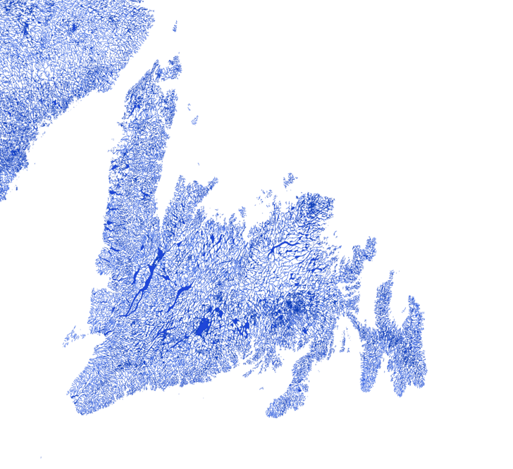

Photo: Vivid Maps (“Canada mapped only by rivers, streams and lakes”)

North Atlantic Worlds is a joint meeting of the Canadian Association for Irish Studies (CAIS) and the Social Sciences and Humanities Oceans Research and Education network (SSHORE), organized by Danine Farquharson (Memorial University) and Julia M. Wright (Dalhousie University).

The organizers welcome submissions on “North Atlantic Worlds.” We take “worlds” broadly, to consider the Atlantic as a diverse space of undersea worlds and coastal worlds, a bridge between the “Old” and “New” worlds, diasporic worlds and territorial worlds, utopian and dystopian worlds, past worlds and future worlds. We are open to proposals from any discipline in the Social Sciences or Humanities, and from such fields as ocean studies, Indigenous studies, Irish studies, environmental studies, and/or transatlantic studies.

The conference dates overlap with that of the International Small Island Studies Association’s meeting, also being held in St. John’s, and we expect to have some joint panels and events.
Featured Keynotes:
Lisa McInerney (author of The Glorious Heresies and The Blood Miracles)
Dr. Willeen Keough (Professor of History, Simon Fraser University)

We welcome submissions on such topics as (but not limited to):

The Galway Statement (2013)

Traditional fisheries

The Irish diaspora in North America

Ocean energies and environments

Maritime masculinities: from adventure narratives to gendered work

Imagining islands

Coastal communities and ecologies

The ocean in Irish literature and visual art

Migrant narratives

Oceans and the law

Environmental policy

The ocean in folklore and/or spiritual beliefs

Treaties

Please send proposals of 300-400 words and a brief bio-note to the organizers at:

atlanticworlds2020@gmail.com

no later than 15 February 2020.

